# DAD 220 Module Three Major Activity Database Documentation Template

Complete these steps as you work through the directions for this activity. Replace the bracketed text with your screenshots and brief explanations of the work they capture. Each screenshot and its explanation should be sized to approximately one quarter of the page, with the description written below the screenshot. Follow these rules for each of the prompts and questions below. Review the example document for assistance.

## Step One: Create a Database

1. Navigate to your online integrated development environment (IDE). Here, you will need to write the proper SQL commands in command line to create tables that demonstrate relationships based on the entity relationship diagram. List and record the SQL commands that you used to complete this step here:

[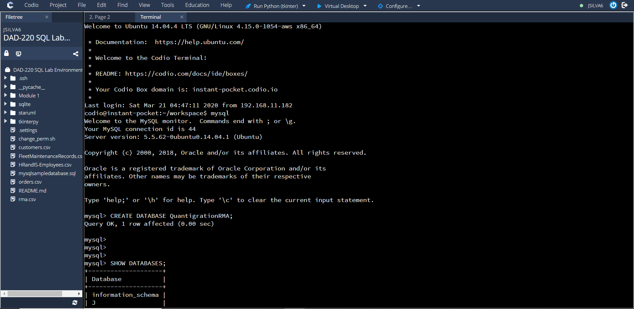

I created a new terminal in Codio and inputed the command mysql to access mysql.]

1. Create a database schema called *QuantigrationRMA*. List out the database name. Provide the SQL commands you ran against MySQL to successfully complete this in your answer:

[

I create the database named QuantigrationRMA by using the command CREATE DATABASE QuantigrationRMA;. I then used the command SHOW DATABASES; to show my created databases.]

1. Using the ERD as a reference, **create the following tables with the appropriate attributes and keys**:
   1. A table named **customers** in the *QuantigrationRMA* database as defined on the project ERD. Provide the SQL commands you ran against MySQL to complete this successfully in your answer:

[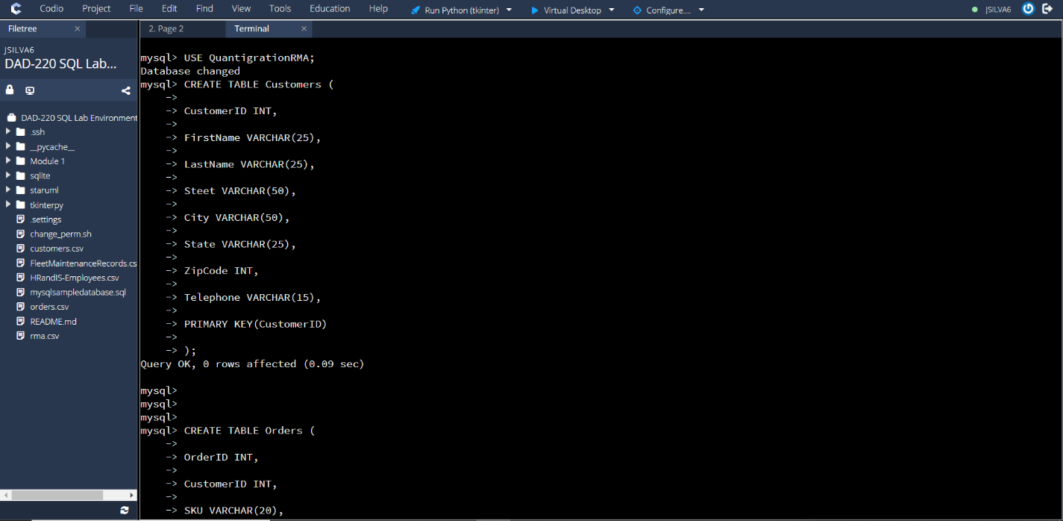

I created a table named Customers in the QuantigrationRMA database. I then added columns, rows, and cells in the Customers table. I used the command CREATE TABLE Customers (CustomerID INT, …. PRIMARY KEY(CustomerID));.]

* 1. A table named **orders** in the *QuantigrationRMA* database as defined on the project ERD. Provide the SQL commands you ran against MySQL to complete this successfully in your answer:

[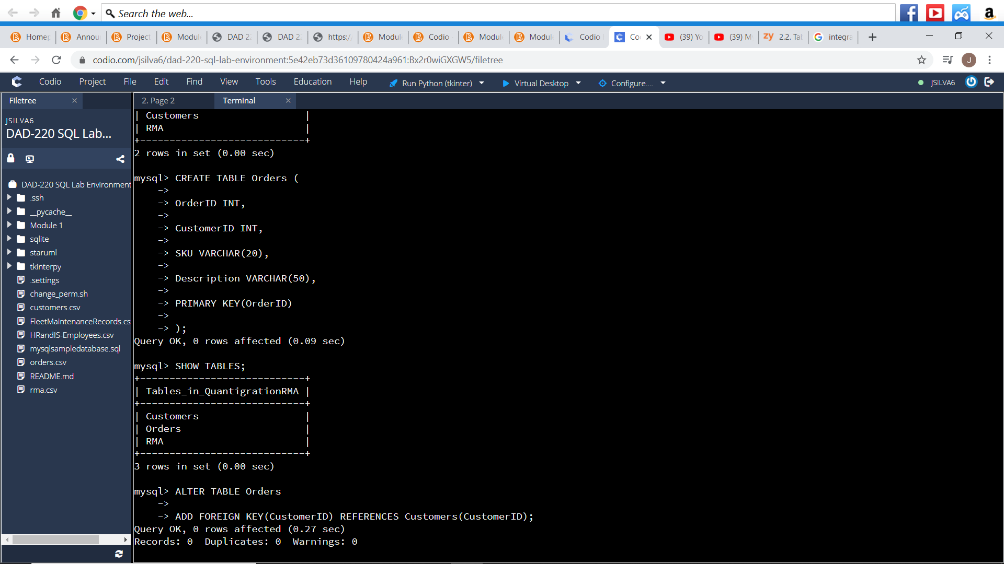I created a table named Orders in the QuantigrationRMA database. I originally messed up in my coding by forgetting to put a comma behind Description VARCHAR(50) and I made an error. I then added a comma and then created the Orders TABLE. I then added columns, rows, and cells in the Orders table. I used the command CREATE TABLE Orders (OrderID INT, …. PRIMARY KEY(OrderID));.]

* 1. A table named **rma** in the *QuantigrationRMA* database as defined on the project ERD. Provide the SQL commands you ran against MySQL to complete this successfully in your answer:

[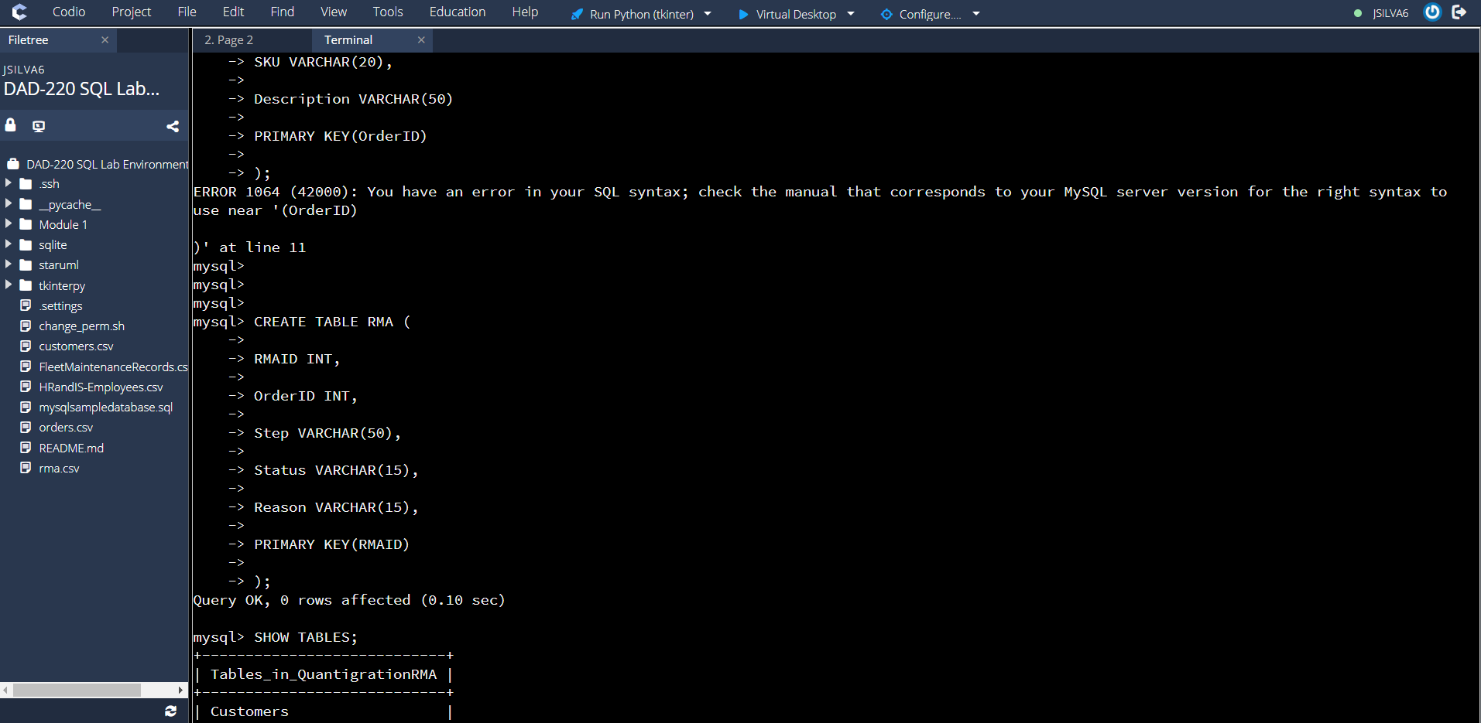I created a table named RMA in the QuantigrationRMA database. I then added columns, rows, and cells in the Orders table. I used the command CREATE TABLE RMA (RMAID INT, …. PRIMARY KEY(RMAID));.]

1. **Update your existing table** from “Customer” to “Collaborator” using SQL based on this change in requirements. Provide the SQL commands you ran against MySQL to complete this successfully in your answer:

[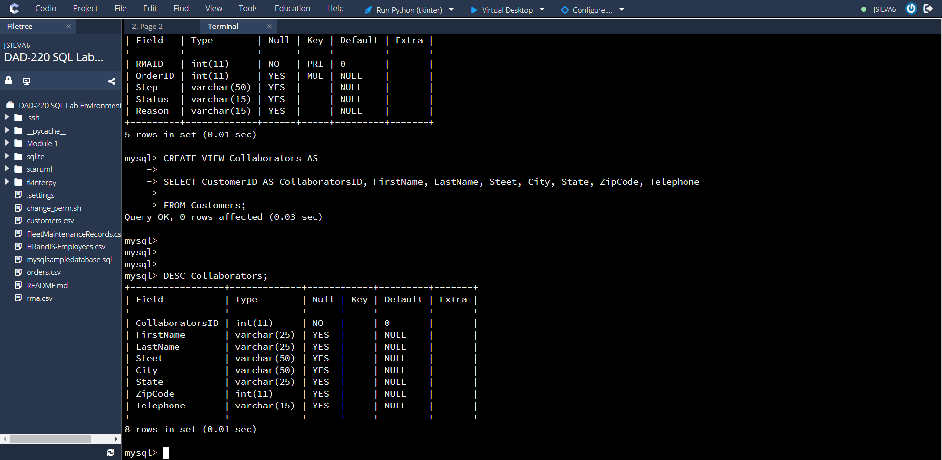I took the video’s advice and used a view command instead of renaming Customer to Collaborators because I also used the Command ALTER TABLE Customers Rename Collaborator; The output of this command did not change CustomerID to CollaboratorID. I used the commands CREATE VIEW Collaborators AS SELECT CustomerID as CollaboratorsID….. FROM Customers;. Using this command, the Collaborators Table had the same information as the Customers Table, but the word Customers throughout the table was replaced with Collaborators.]